11. Scenario : You are a data scientist working for a company that sells products online. You have

been tasked with creating a simple plot to show the sales of a product over time.

Question:

1. Write code to create a simple line plot in Python using Matplotlib to predict sales happened in a

month?

2. Write code to create a scatter plot in Python using Matplotlib to predict sales happened in a

month?

3. Develop a Python program to create a bar plot of the monthly sales data.

**Code**:

import pandas as pd

import matplotlib.pyplot as plt

df = pd.read_csv(r"C:\Users\jampa\Downloads\monthly_sales_data (1).csv")

plt.figure(figsize=(15, 12))

# 1.Line Plot

plt.subplot(3, 1, 1)

plt.plot(df['Month'], df['Sales'], marker='o', linestyle='-', color='blue')

plt.title('Monthly Sales Trend (Line Plot)')

plt.xlabel('Month')

plt.ylabel('Sales')

plt.xticks(rotation=45)

plt.grid(True)

# 2.Scatter Plot

plt.subplot(3, 1, 2)

plt.scatter(df['Month'], df['Sales'], color='red')

plt.title('Monthly Sales (Scatter Plot)')

plt.xlabel('Month')

plt.ylabel('Sales')

plt.xticks(rotation=45)

plt.grid(True)

# 3.Bar Plot

plt.subplot(3, 1, 3)

plt.bar(df['Month'], df['Sales'], color='green')

plt.title('Monthly Sales (Bar Plot)')

plt.xlabel('Month')

plt.ylabel('Sales')

plt.xticks(rotation=45)

plt.tight_layout()

plt.show()

**output:**

1.line plot

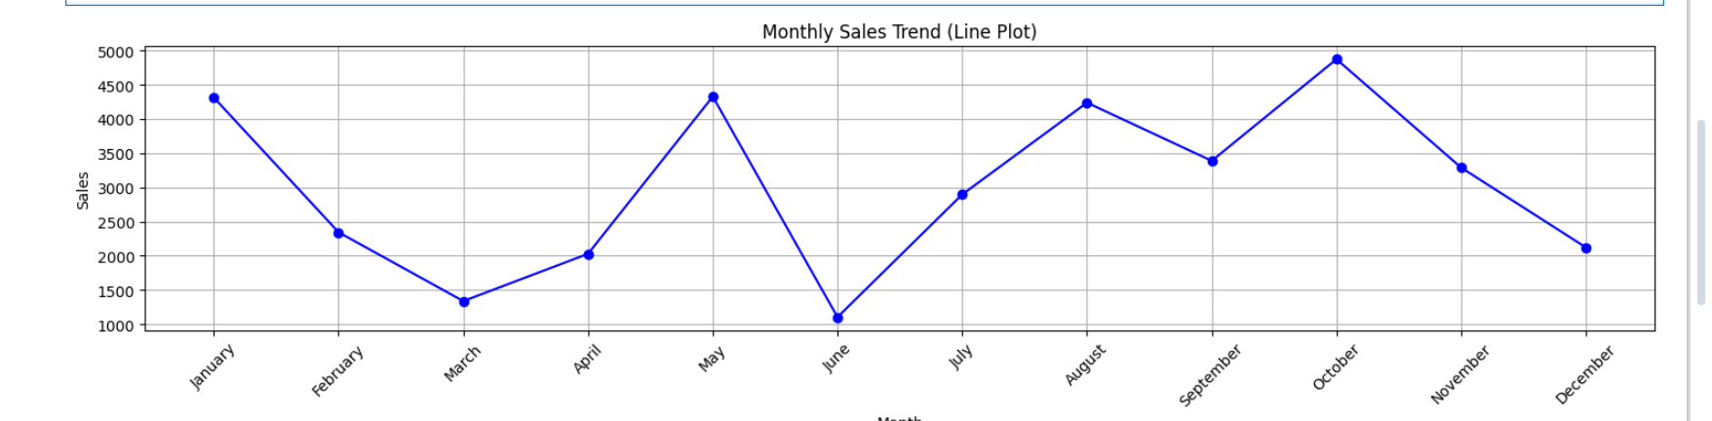

2.scatter plot

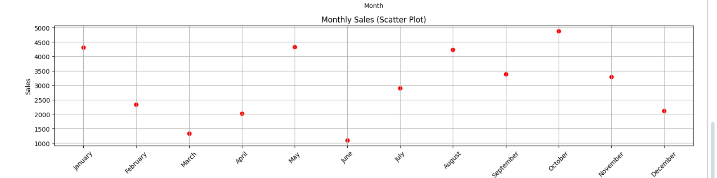

3.bar plot

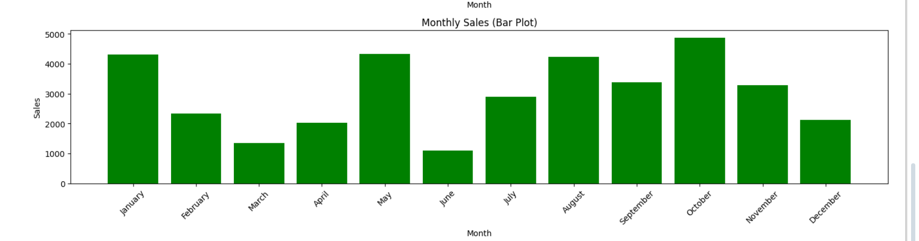

**Dataset:**

|  |  |
| --- | --- |
| Month | Sales |
| January | 4313 |
| February | 2344 |
| March | 1338 |
| April | 2029 |
| May | 4327 |
| June | 1104 |
| July | 2897 |
| August | 4238 |
| September | 3388 |
| October | 4873 |
| November | 3288 |
| December | 2122 |